# Lab: Reflection and Annotations

This document defines the lab for the ["Java Advanced" course @ Software University](https://softuni.bg/modules/59/java-advanced). Please submit your solutions (source code) to all below-described problems in [Judge](https://judge.softuni.bg/Contests/1604/Reflection-Lab).

# Part I: Reflection

## Reflection

Import "Reflection.java" to your "src" folder in your project. Try to use **reflection** and print some information about this class. Print everything on a new line:

* **This class type**
* **Super class type**
* **All interfaces** that are implemented by this class
* **Instantiate object** using reflection and print it too

**Don’t change anything in "Reflection class"!**

### Solution

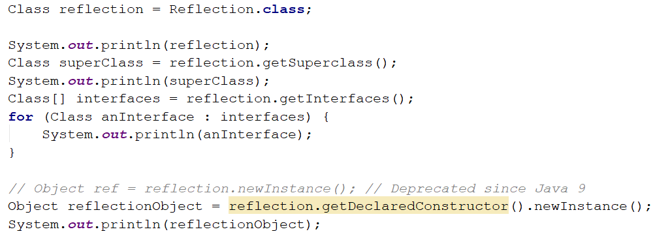

## Getters and Setters

Use reflection to get all Reflection methods. Then prepare an algorithm that will recognize, which methods are **getters** and **setters**. Sort each collection **alphabetically** by methods names. Print to console each **getter** on a new line in the format:

* "{name} will return class {Return Type}"

Then print all **setters** in the format:

* "{name} and will set field of class {Parameter Type}"

**Do this without changing anything in** "Reflection.java"

## High Quality Mistakes

You are already an expert on **High-Quality Code**, so you know what kind of **access modifiers** must be set for members of the class. The time for **revenge** has come. Now you have to check the code produced by your "**Beautiful and Smart**" trainers in class Reflection. Check all **fields and methods access modifiers**. Sort each category of members **alphabetically**. Print on the console all **mistakes** in the format:

* For Fields:

"**{fieldName} must be private!**"

* For Getters:

"{methodName} have to be public!"

* For Setters:

"{methodName} have to be private!"

# Part II: Annotations

## Create Annotation

Create annotation Subject with a String[] element called **categories**, that:

* Should be available at runtime
* Can be placed only on types

### Examples

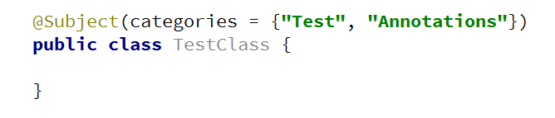

## Coding Tracker

Create annotation Author with a String element called **name**, that:

* Should be available at runtime
* Can be placed only on methods

Create a class **Tracker** with a method:

* public static void printMethodsByAuthor()

### Examples

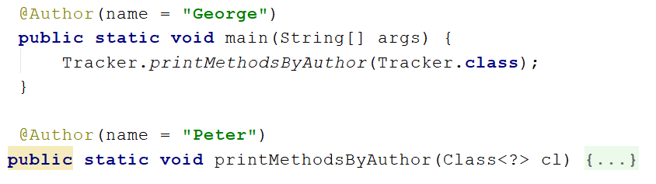

### Output

